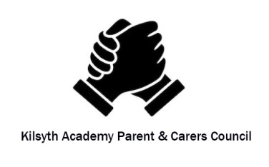
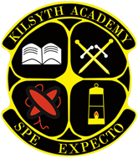
KILSYTH ACADEMY
Parent council Minutes , 25/11/2020)

In Attendance
G. Orrock, C. Kay, T Clinton, J Machray, G Anderson -Chair, J Ballantyne, C Hamilton, N Devlin, G Bartlett, K McNiven, H Thomson
Apologies: L Daisley, A Brodie

Welcome
- The meeting took place on the Microsoft Teams platform.

- G Orrock opened the meeting by welcoming everyone to the meeting and reminding all that this is the Parent and Carers Council (PCC) meeting not a School meeting.

Chairman Report
- G Anderson attended the Parent Council Consultation with 64 PCCs being represented through North Lanarkshire Council (NLC). GA found it very informative.
- NLC have issued 1200 electronic devises with a further 1200 being issued prior to Christmas.
- 4000 pupils are self-isolating within NLC with 120 schools affected.
- 2 Slide shows were presented; digital learning and the role of the PCC. If anyone has any questions contact GA
- Trying to establish a generic email address for PCC for each school.
- Funding is available to PCC; GA to contact school and arrange applying for funds.
- PCC has Insurance Cover
- Minutes of PC meetings to be issued to NLC
- PCc members to confirm email address to GA for forwarding onto NLC
- GA and CH are going on the training course for selection panels.

Treasurer’s report
- No Treasurer’s report at this meeting

Head Teacher’s report
G Orrock reported back to the meeting as follows:
- Refunded trips pre-Covid – these have all now been refunded.
- The School Tower was lit purple. This was in conjunction with the Rotary Club to highlight ending Polio. This was positive for the school and something that may be explored further.
- S1’s got some of the Halloween experience; the school is now going to see if some of the Crazy Day can be implemented as it is important not to let Covid dictate the School experience.
- Science dept are going to run a STEM club online
- There is a Pilot online supported study for Science- positive feedback from one of the PCC regarding the first session.
- SQA will be issuing information regarding assessments for Nat 4 and Nat 5.
- Show my Homework has been relaunched.
- SQA exam diet starts 11th May. Running Mid-Term assessment will be in the last 2 weeks in January 2021. If the exams are cancelled these are a very important marker to determine grade.
- School Calendar. Parents Evening – hoping to finalise calendar within next 2 weeks. The Unions/NLC agreed the format for the Parents Evenings; a full written report will be issued.
- Teams training was undertaken during the September in-service day

COVID- 19 Update by Head Teacher
- NLC being put into Tier 4 does change some things for the school
- PE must be outside – this does have present a challenge in the colder months.
- Young people who are shielding have to stay at home for 3 weeks.
- Tier 4 requires a good level of ventilation and a minimum temp of 17⁰C. This means pupils will take off jackets but are allowed increased layers.
- NLC have introduced a heating boost in the morning and a further boost at lunch.
- 3 weeks before the Christmas holidays – Kilsyth Academy has been COVID free; with no pupil or staff member testing positive. There has been 31 instances of self -isolating. This is either through the Test and Protect app or close family members having to quarantine or shield.
- 4th/5th and 6th year compliance with wearing face coverings is good. In general less disposable face masks are being issued by the school however it is still too many.
- 40 laptops have been issued to pupils with no access to technology.
- There is still a concern with parents/carers dropping off the pupils within the school grounds. Encouragement by all not to enter the school premises for drop off or pick up of pupils. There is a safety concern regarding dropping off pupils outside the gates as it is a tight corner.

AOB
- PCC congratulated the HT regarding the recent online award ceremony. It was very well done.
- Pupil Council committees are now up and running (5 no) and a full update will be given at the next meeting.
- GA confirmed

Dates for next meeting:
Wednesday 13th January 2021 at 6.30pm via Teams.

